## **Variable Scope and Functions**

## **Definition of Scope:** The scope of a variable is the part of a program that can ‘see’ that variable.

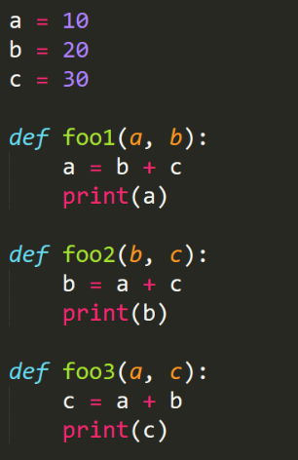

**For the next questions use the code to the right.**

1) What is the output from the following functions?

* 1. foo1(3, 4) =34
  2. foo2(5, 6)=16
  3. foo3(7, 8)=27
  4. foo1(foo2(1, 2), foo3(3, 4))=a.53,b.12,c.23

2) Rewrite the function **foo1** so the variable b is using the globally scoped variable **b.**

**def foo1(a):**

**a=b+c**

**print(a)**

3) Write a single function that takes 3 variables and which finds the sum of the local and global variables and returns both of them.

def combine():

print("Global Sum:",a+b+c)

print("Local Sum:",foo1(a,b)+foo2(b,c)+foo3(a,c))

**For the next question use the code to the right.**

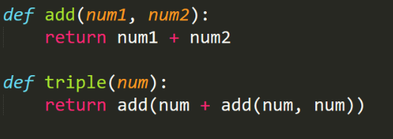

4) Copy this code into a file and then write the function quadruple.

def quadruple(num):

return add(add(num,num),add(num,num))

**For the next questions create a new project in Pycharm (or do in the folder where your current project resides) and add two files:**

**main.py**

**module1.py**

5) In **module1** create a variable called **var1** and assign it the value of “In Module 1”

6) In **main** you can now use the **import** keyword to load all of **module1** to be used inside **main.** Now try print out **var1** inside **main.** The **main.py** file will look like the following:

**import module1**

**print(module1.var1)**

7) Create a function inside **module1** called **say_hello** which takes a single variable and prints out hello to the user. Use this function inside of **main.**

8) Now, instead of using just the **import** keyword, also use the **from** keyword to just bring in the function **say_hello** like the following:

**from module1 import say_hello**

Show how this can used without having to do **module1.say_hello(“Tom”)**

9) Inside the **main** file create function also called **say_hello** but make it tell the user they smell bad instead of saying hello. Call this function. Which one is used? The one in **main** or the one in **module1**?

-The one in main

10) Let’s now try to import some other modules which are part of Python. The math module is quite popular and can be imported by doing the following:

**import math**

(Sorry British speakers, there’s no ‘s’ for this module)

List of all functions in math: <https://docs.python.org/3/library/math.html>

Pick 5 different math functions and test them out.

11) Now, import just the **sqrt** function from math using **from**. What happens if you create

your own **sqrt** function inside of the **main** file?

-It uses the function defined in the main file instead of the function in math.